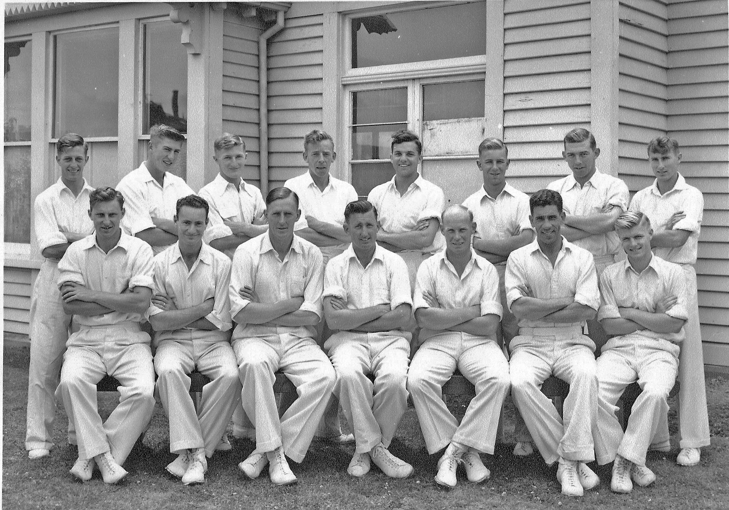

**Canterbury Representative Team 1957/58**

**Back Row:** BA Bolton, RC Motz, AF Rapley, JW Kiddey, BJ Bayley, DL Gallop, DW Crowe, GD Alabaster

**Front Row:** JW Guy, W Bell, AR MacGibbon, ME Chapple (captain), MB Poore, SC Guillen, JW D’Arcy